Geometry as Physics

Understanding Gravity as Geometry
If we take a ball and throw it up with initial velocity, initial angle, and initial position, under reasonable conditions (constant gravity, spherical Earth, etc.), we can accurately predict the position and velocity of the trajectory of the ball (for ), and we can get the x and y components of the ball using our angle. This trajectory is unique given these initial conditions, something special to gravity. Conversely, if we are talking about the movement of an electric charge in an electric field, the movement depends on the charge’s strength and sign, and the same characteristics for the field we travel along. It is only in a gravitational field where bodies with the same initial conditions follow the same curve in space and time.
Einstein's theory was basically that we can show the uniqueness of the path of a body moving through a gravitational field can be explained via a four dimensional axis called spacetime, and that any objects with a mass end up bending spacetime, thereby curving it. In the absence of other forces, bodies will move in straight lines in the curved spacetime.

Euclidean Geometry
Euclidean Geometry is basically just the geometry we are used to, three orthogonal coordinates, a unit element that is a perfect cube, etc. If we change the geometry, we change a lot of the physical characteristics of the object we are looking at.

The Circumference of a Circle
What is the circumference of a circle?
If we operate in Euclidean Geometry, we know this answer:
On the surface of the sphere, however, the problem is a little more tricky:
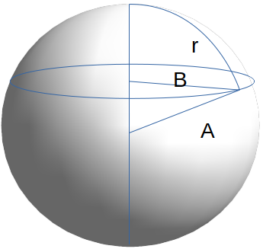
To relate the circumference of a circle drawn on a sphere to the radius of said sphere of radius a, we do the following:

radius of the circle
So,
Essentially, we can visualize Euclidean 2D spaces as projections onto 3D objects. Generally speaking, we can project an n dimensional object onto an n+1 dimensional object and do geometry to be able to get the values of whatever measurements we want. This becomes a problem when we do things in dimensions greater than 3, because it is impossible for us to visualize such high dimensions.
Instead of embedding n dimensional geometries into n+1 dimensional geometries, we can instead specify a number of axioms for each geometry that can describe how our desired geometry works.
Euclid’s Elements explained that we can define our typical Cartesian geometry via a set of 5 axioms:
- 2 points determine a line
- Parallel lines do not intersect
- A circle can be specified by a center point and a radius
- All right angles are equal
- Through any point P on line L, there exists one and only one line on the plane of P and L that does not intersect with L
For a spherical geometry, we can replace axiom 2 by saying parallel lines do meet at 2 points. It’s still somewhat tedious because it needs to be done for each geometry.

The Line Element
To get a better way of expressing geometries, let’s use a simpler model. To find distance between two points on a Cartesian plane, we need only do , and circumference can be determined by taking a closed loop integral of . Essentially, this quantity is able to sum up all of our axioms pretty effectively. This is called the line element of the space, and it is how we will describe the geometries we will use.

Some other example Geometries
Take, we can see that since phi (not the differential element) does not appear in the equation, all geometries here will be symmetric about an axis. The circumference if a circle drawn on it will always be the same as that of a circle but multiplied by the function.
Spherical Geometry: When
Peanut Geometry: When

